KUBERNETES TASK-04
- Deploy an application using a Deployment with 3 replicas and a rolling update strategy.

Step 1: Create YAML file
Create a file:
nano deployment.yaml
Paste this:
apiVersion: apps/v1
kind: Deployment
metadata:
name: nginx-deployment
spec:
replicas: 3
strategy:
type: RollingUpdate
rollingUpdate:
maxUnavailable: 1
maxSurge: 1
selector:
matchLabels:
app: nginx
template:
metadata:
labels:
app: nginx
spec:
containers:
- name: nginx
image: nginx:latest
ports:
- containerPort: 80
Save and exit:
CTRL + O → Enter → CTRL + X

🔹 Step 2: Apply Deployment
- kubectl apply -f deployment.yaml

🔹 Step 3: Check Deployment
- kubectl get deployments
You should see:
- nginx-deployment 3/3 Running

🔹 Step 4: Check Pods
- kubectl get pods
You should see 3 pods running.

🔹 Step 5: Describe Deployment (Verify Strategy)
kubectl describe deployment nginx-deployment
Check:
Strategy = RollingUpdate
MaxUnavailable = 1
MaxSurge = 1

🔹 Step 6: Perform Rolling Update
Update image:
- kubectl set image deployment/nginx-deployment nginx=nginx:1.25

🔹 Step 7: Watch Update Live
kubectl rollout status deployment/nginx-deployment
👉 Pods will update one by one (no downtime)

🔹 Step 8: Verify Again
- kubectl get pods
New pods will be created with updated image.
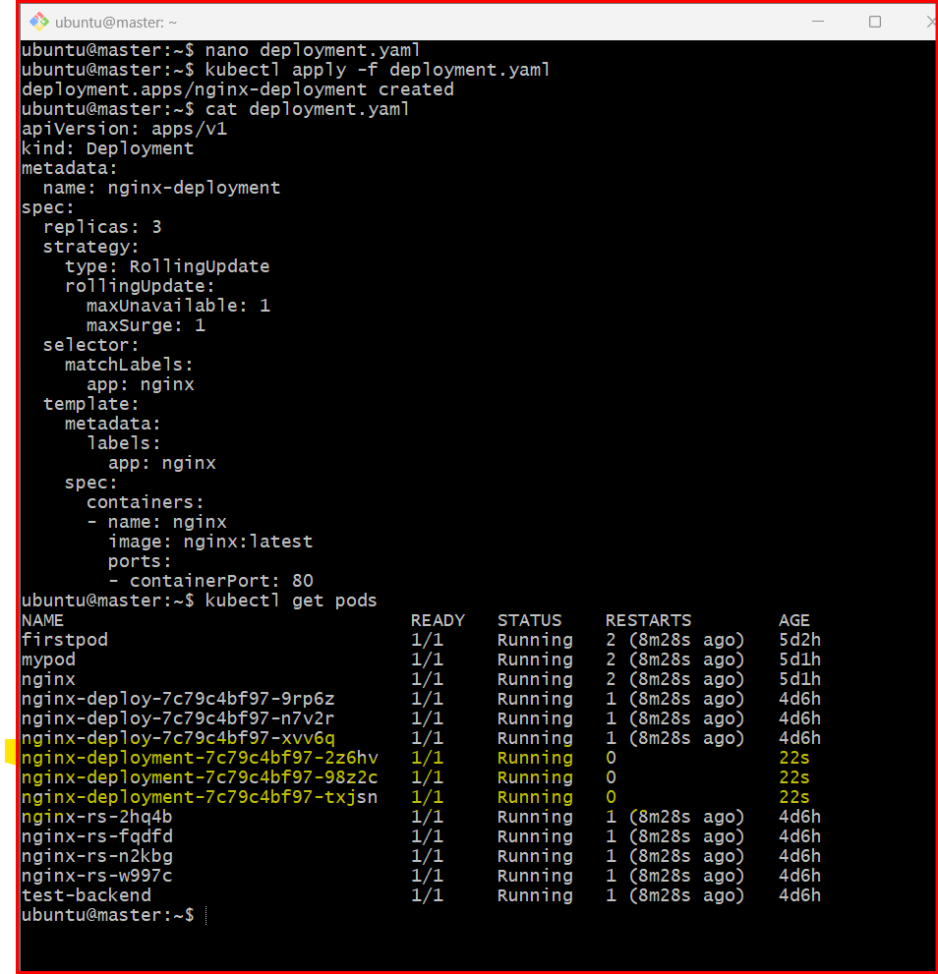

🔹 Step 9: Rollback (if needed)
- kubectl rollout undo deployment/nginx-deployment

✅ Summary
3 replicas → High availability
Rolling update → Zero/minimal downtime
Easy update + rollback

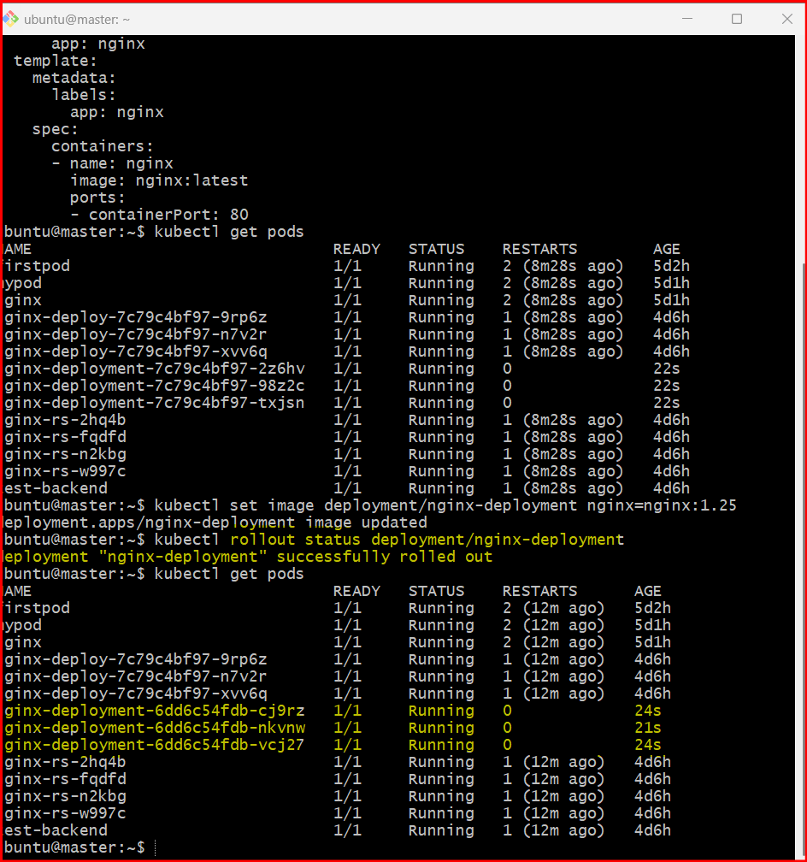

- Configure a Deployment with a Recreate strategy and observe the downtime.

Step 1: Create YAML file
- nano recreate-deployment.yaml
Paste this:
apiVersion: apps/v1
kind: Deployment
metadata:
name: recreate-deployment
spec:
replicas: 3
strategy:
type: Recreate # 🔥 Important
selector:
matchLabels:
app: myapp
template:
metadata:
labels:
app: myapp
spec:
containers:
- name: nginx
image: nginx:1.24
ports:
- containerPort: 80
Save:
CTRL + O → Enter → CTRL + X

🔹 Step 2: Apply Deployment
- kubectl apply -f recreate-deployment.yaml

🔹 Step 3: Verify Pods
- kubectl get pods
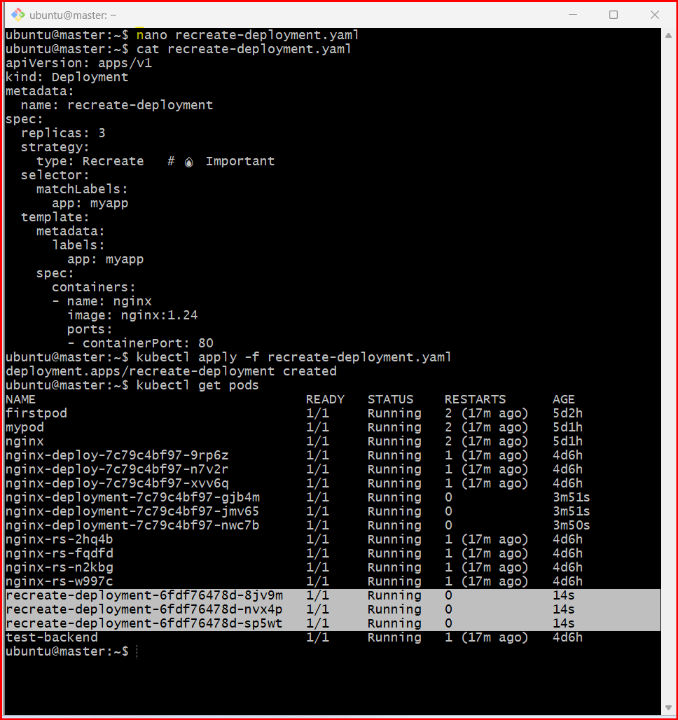
👉 You should see 3 running pods

🔹 Step 4: Expose Deployment (IMPORTANT for testing downtime)
- kubectl expose deployment recreate-deployment --type=NodePort --port=80
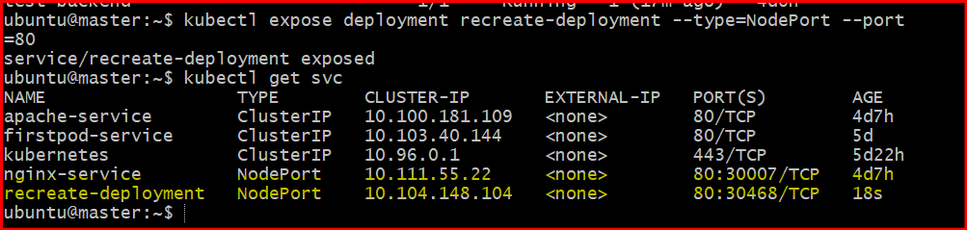
Get service:
- kubectl get svc
Note the NodePort (example: 30007)

🔹 Step 5: Access Application
Open in browser:
http://54.86.165:30468

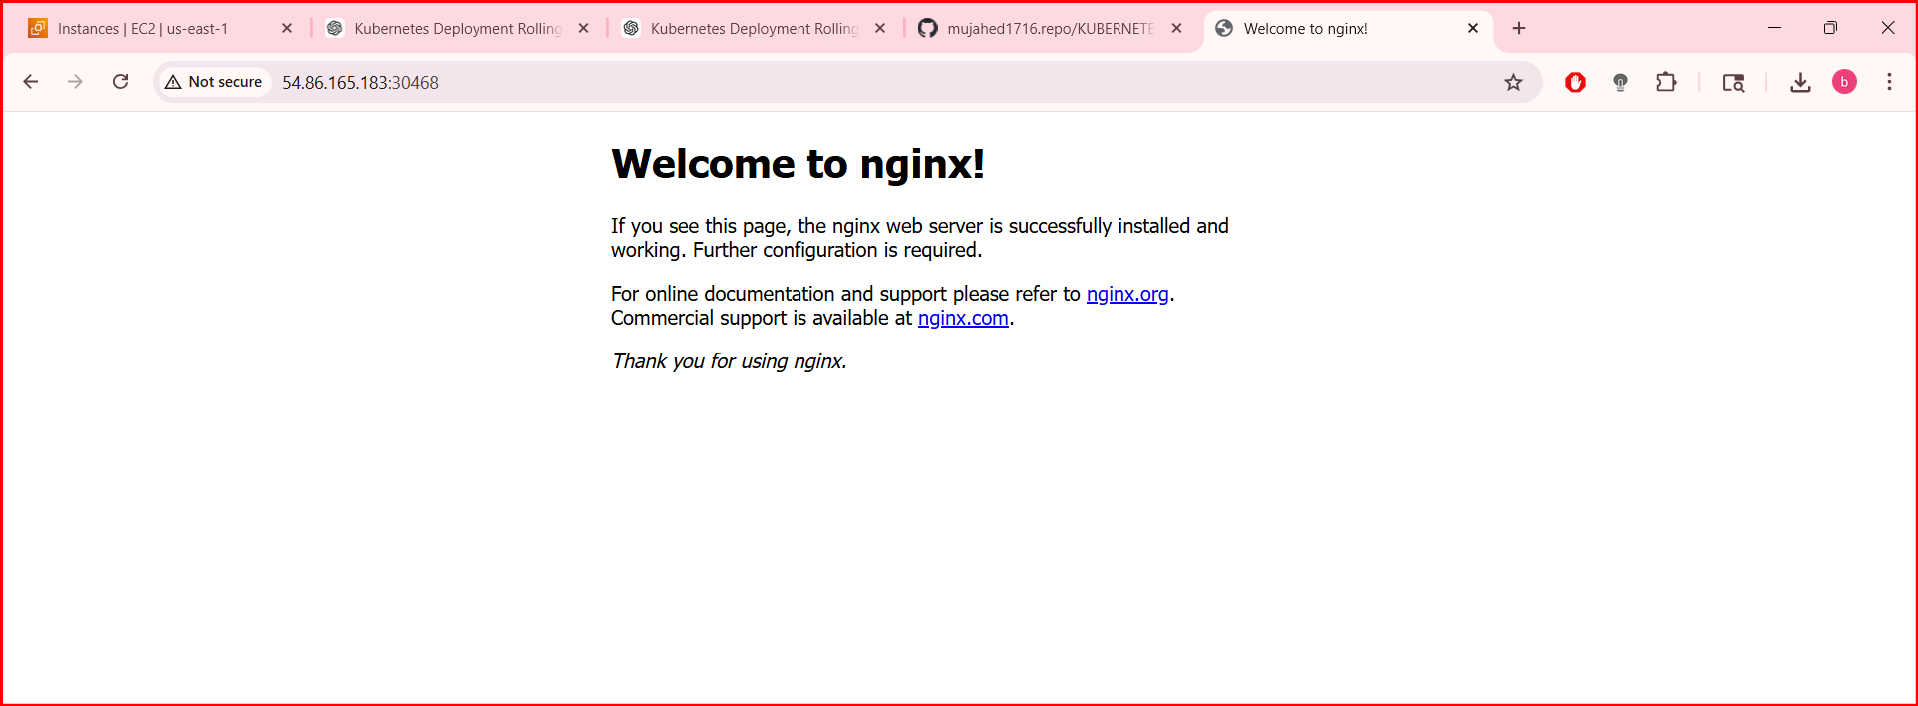
OR use curl:
curl http://54.86.165:30468
👉 You should see nginx welcome page

🔹 Step 6: Start Continuous Request (to observe downtime)
Run this in a loop:
while true; do curl -s http://<NodeIP>:<NodePort>; sleep 1; done
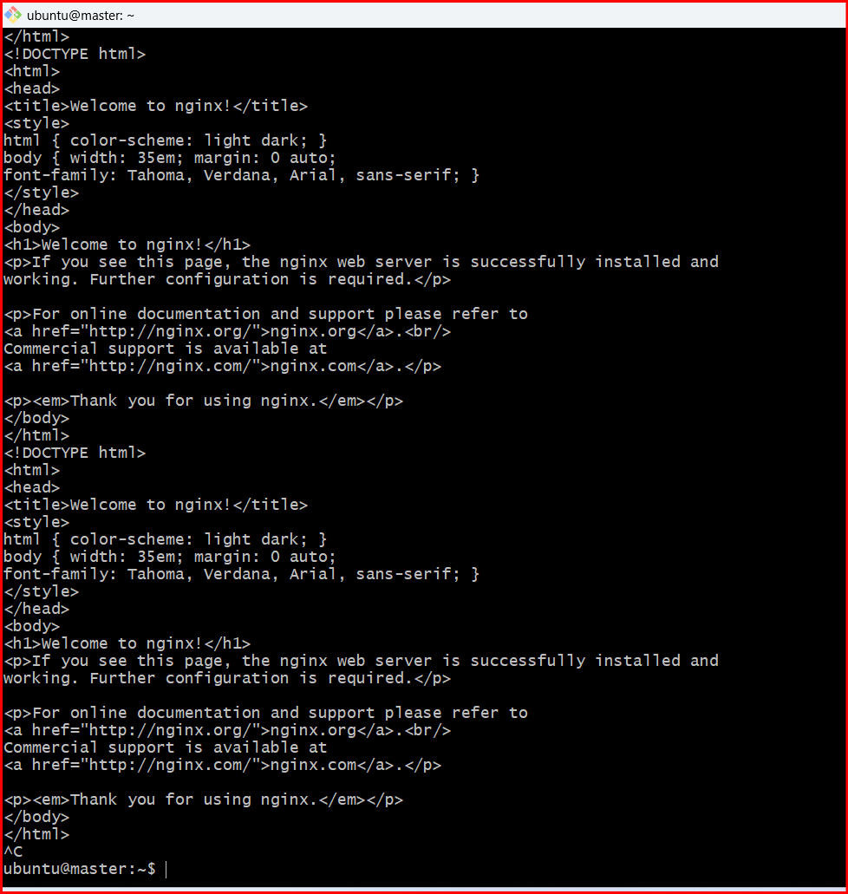

🔹 Step 7: Trigger Recreate Update
Update image:
- kubectl set image deployment/recreate-deployment nginx=nginx:1.25

🔹 Step 8: Observe Downtime 🔥
Watch pods:
kubectl get pods –w

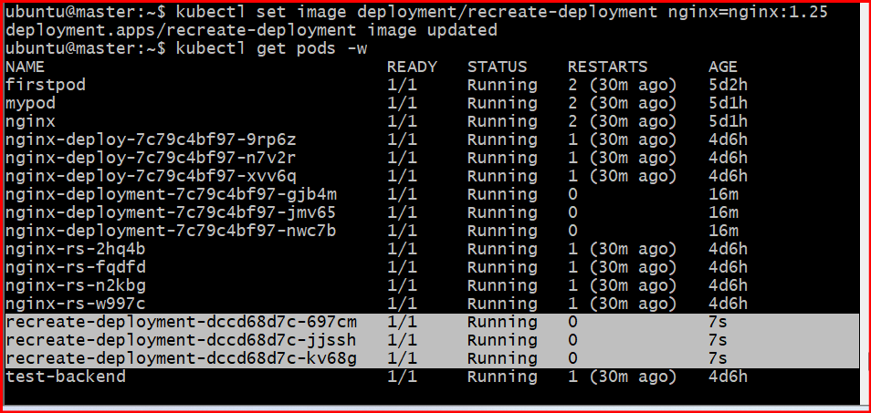
👉 What happens:
- All old pods are TERMINATED first
- Then new pods are CREATED
👉 During this gap:
- Your curl/browser will show:
  - ❌ Connection refused OR timeout
✔️ This is downtime

🔥 Key Difference
Strategy | Behavior
RollingUpdate | No downtime
Recreate | Downtime (all pods stop first)

🔹 Step 9: Confirm New Pods
kubectl get pods
All pods will come back with new version.
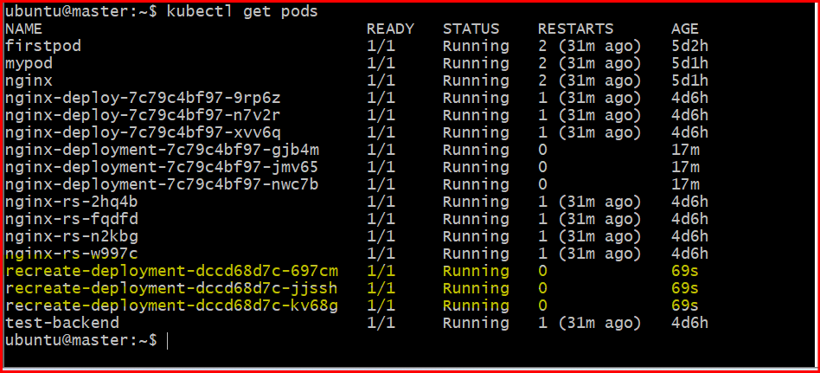
- Update an existing Deployment and perform a rollback to the previous version.

Step 1: Create Deployment (initial version)
- nano deployment.yaml
Paste:
apiVersion: apps/v1
kind: Deployment
metadata:
name: my-deployment
spec:
replicas: 3
selector:
matchLabels:
app: myapp
template:
metadata:
labels:
app: myapp
spec:
containers:
- name: nginx
image: nginx:1.24 # initial version
ports:
- containerPort: 80
Save and exit.

🔹 Step 2: Apply Deployment
- kubectl apply -f deployment.yaml

🔹 Step 3: Verify Running Pods
- kubectl get pods
👉 Ensure 3 pods are running

🔹 Step 4: Check Deployment History
kubectl rollout history deployment/my-deployment
👉 You’ll see revision 1
AS I am having many pods deployment it is showing some issue
Let’s use nginx-deployment (you already have it running)

🔹 Step 1: Check Deployment
- kubectl get deployments

🔹 Step 2: Get container name
- kubectl describe deployment nginx-deployment
Look for:
Containers:
nginx:
👉 Container name = nginx

🔹 Step 3: Check rollout history
- kubectl rollout history deployment/nginx-deployment

🔹 Step 4: Update image
- kubectl set image deployment/nginx-deployment nginx=nginx:1.25

🔹 Step 5: Watch update
- kubectl rollout status deployment/nginx-deployment

🔹 Step 6: Check history again
- kubectl rollout history deployment/nginx-deployment
👉 Now you’ll see multiple revisions

🔹 Step 7: Rollback
- kubectl rollout undo deployment/nginx-deployment

🔹 Step 8: Verify rollback
- kubectl get pods
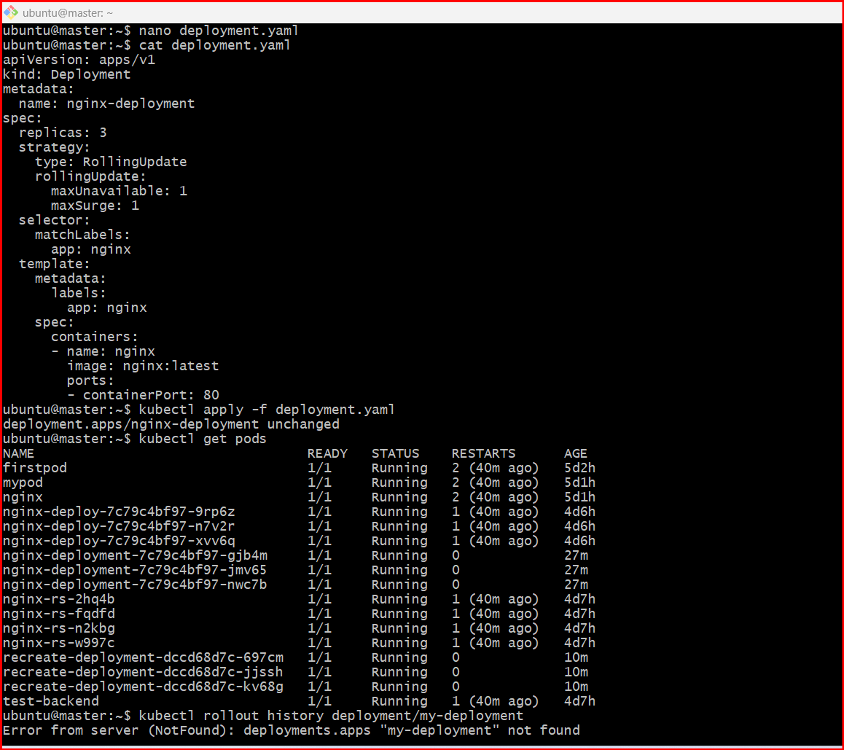

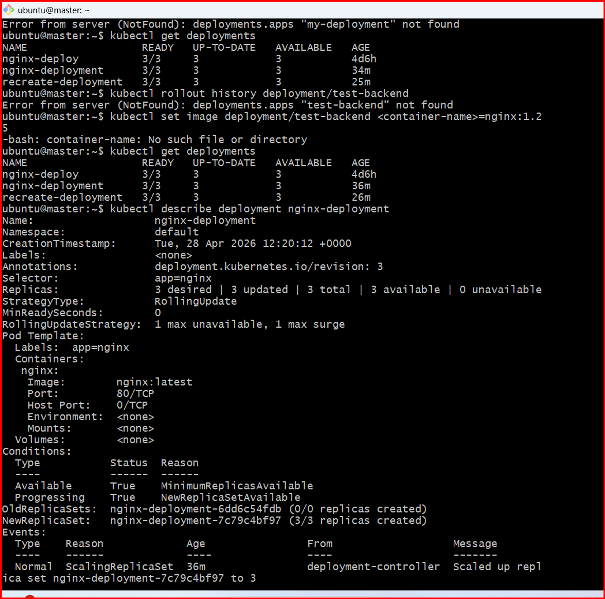
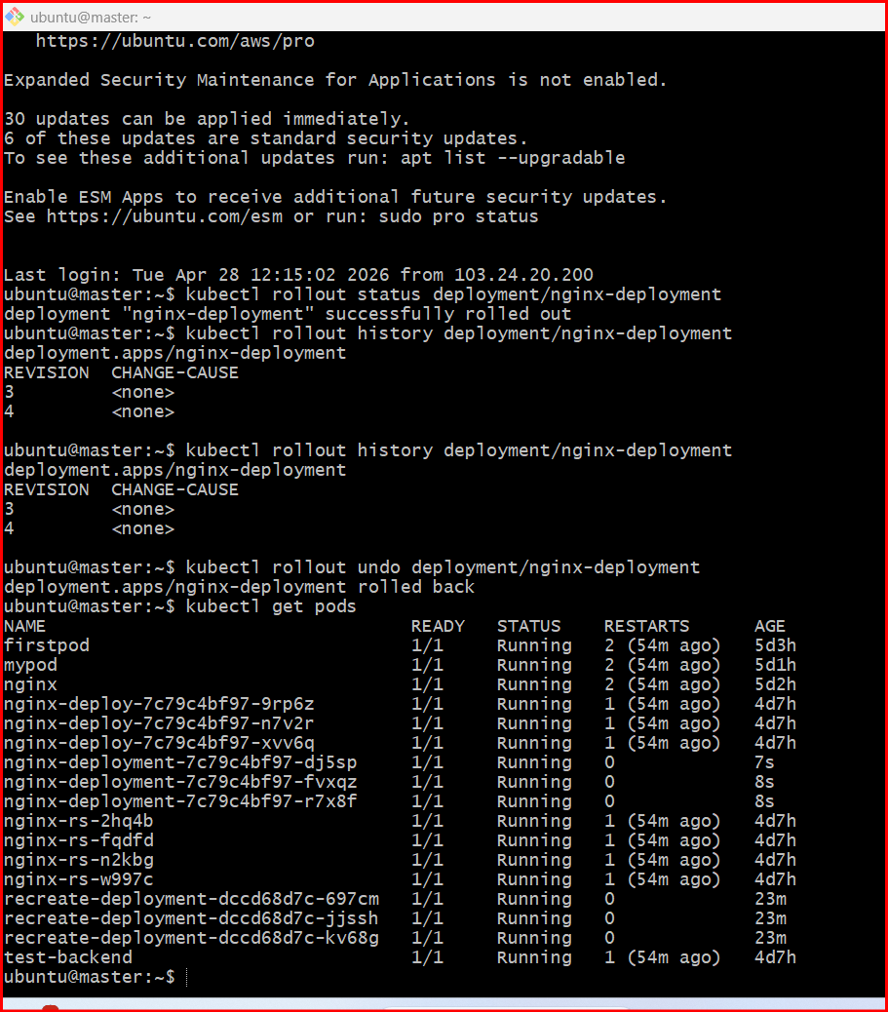

- Modify a Deployment to add resource requests and limits for CPU and memory.

Step 1: Choose your Deployment
From your cluster, you can use:
- kubectl get deployments
👉 Example: nginx-deployment

🔹 Step 2: Edit the Deployment
- kubectl edit deployment nginx-deployment

🔹 Step 3: Add resources section
Inside the container spec, modify like this:
spec:
containers:
- name: nginx
image: nginx:latest
resources:
requests:
cpu: "100m"
memory: "128Mi"
limits:
cpu: "200m"
memory: "256Mi"

🔹 Step 4: Save & Exit
- Press i (if using vi editor)
- Paste/edit
- Press ESC
- Type :wq and hit Enter

🔹 Step 5: Verify rollout
- kubectl rollout status deployment/nginx-deployment

🔹 Step 6: Verify resources applied
- kubectl describe deployment nginx-deployment
OR check a pod:
kubectl describe pod <pod-name>
👉 Look for:
- Requests: CPU 100m, Memory 128Mi
- Limits: CPU 200m, Memory 256Mi
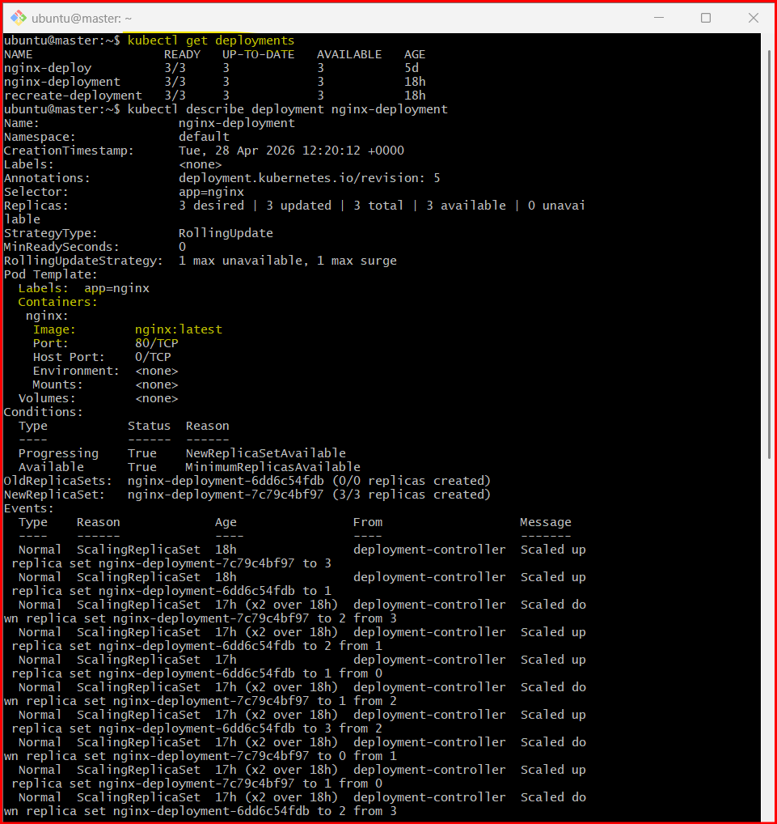

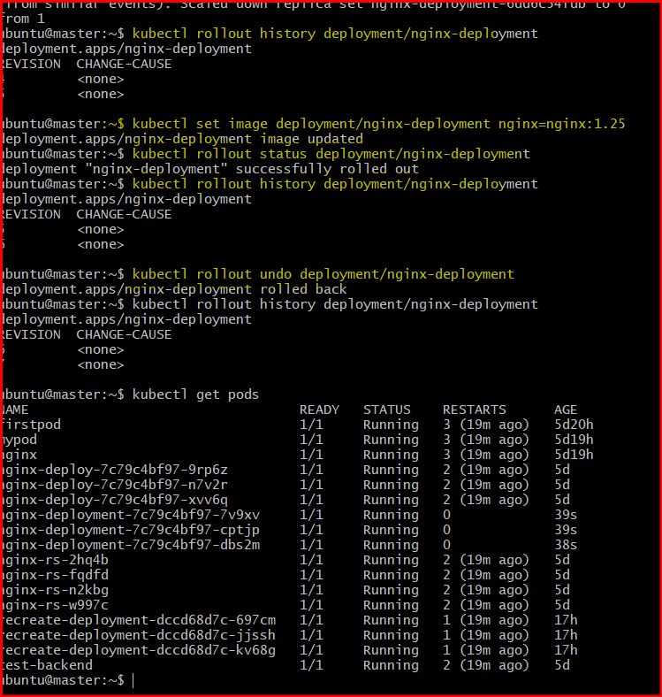

- Create a Deployment with MaxSurge and MaxUnavailable configurations.

Step 1: Create YAML file
- nano surge-deployment.yaml

🔹 Step 2: Add configuration
Paste this:
apiVersion: apps/v1
kind: Deployment
metadata:
name: surge-deployment
spec:
replicas: 3
strategy:
type: RollingUpdate
rollingUpdate:
maxSurge: 1 # extra pods allowed during update
maxUnavailable: 1 # pods that can be unavailable
selector:
matchLabels:
app: surge-app
template:
metadata:
labels:
app: surge-app
spec:
containers:
- name: nginx
image: nginx:1.24
ports:
- containerPort: 80

🔹 Step 3: Apply Deployment
- kubectl apply -f surge-deployment.yaml

🔹 Step 4: Verify Deployment
- kubectl get deployments

🔹 Step 5: Check Pods
- kubectl get pods
👉 You should see 3 pods running

🔹 Step 6: Verify Strategy
- kubectl describe deployment surge-deployment
Look for:
- Strategy: RollingUpdate
- MaxSurge: 1
- MaxUnavailable: 1

🔹 Step 7: Trigger Update
- kubectl set image deployment/surge-deployment nginx=nginx:1.25

🔹 Step 8: Watch Rolling Update
- kubectl get pods -w

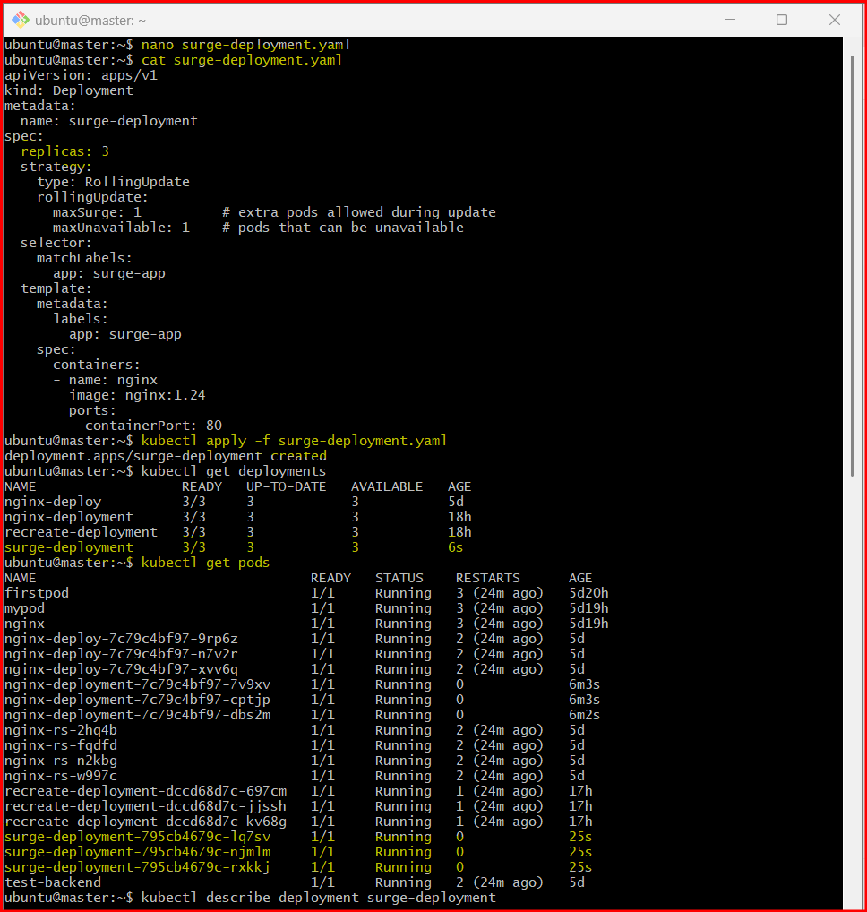

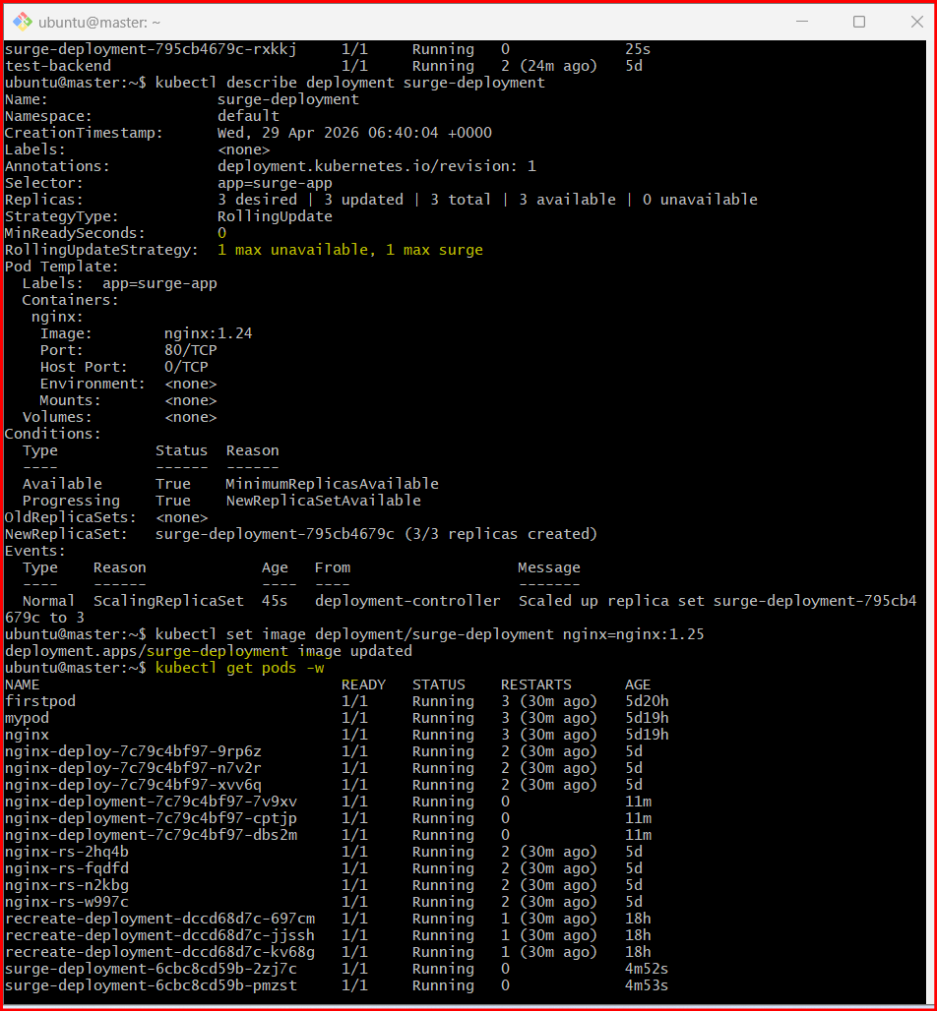

- Set up a Deployment with a custom revision history limit.

Step 1: Create YAML file
- nano revision-deployment.yaml

🔹 Step 2: Add configuration
Paste this:
apiVersion: apps/v1
kind: Deployment
metadata:
name: revision-deployment
spec:
replicas: 3
revisionHistoryLimit: 2 # 🔥 Keep only last 2 revisions
strategy:
type: RollingUpdate
selector:
matchLabels:
app: revision-app
template:
metadata:
labels:
app: revision-app
spec:
containers:
- name: nginx
image: nginx:1.24
ports:
- containerPort: 80

🔹 Step 3: Apply Deployment
kubectl apply -f revision-deployment.yaml

🔹 Step 4: Verify Deployment
kubectl get deployments

🔹 Step 5: Check Revision History
kubectl rollout history deployment/revision-deployment
👉 Initially:
REVISION CHANGE-CAUSE
1 <none>

🔹 Step 6: Create Multiple Revisions
Run updates:
kubectl set image deployment/revision-deployment nginx=nginx:1.25
kubectl set image deployment/revision-deployment nginx=nginx:1.26
kubectl set image deployment/revision-deployment nginx=nginx:1.27

🔹 Step 7: Check History Again
kubectl rollout history deployment/revision-deployment
👉 Output will show only last 2 revisions, for example:
REVISION CHANGE-CAUSE
3 <none>
4 <none>
👉 Older revisions are automatically deleted

🔥 What This Means
- revisionHistoryLimit: 2
  - Keeps only 2 previous versions
  - Saves cluster memory
  - Limits rollback options
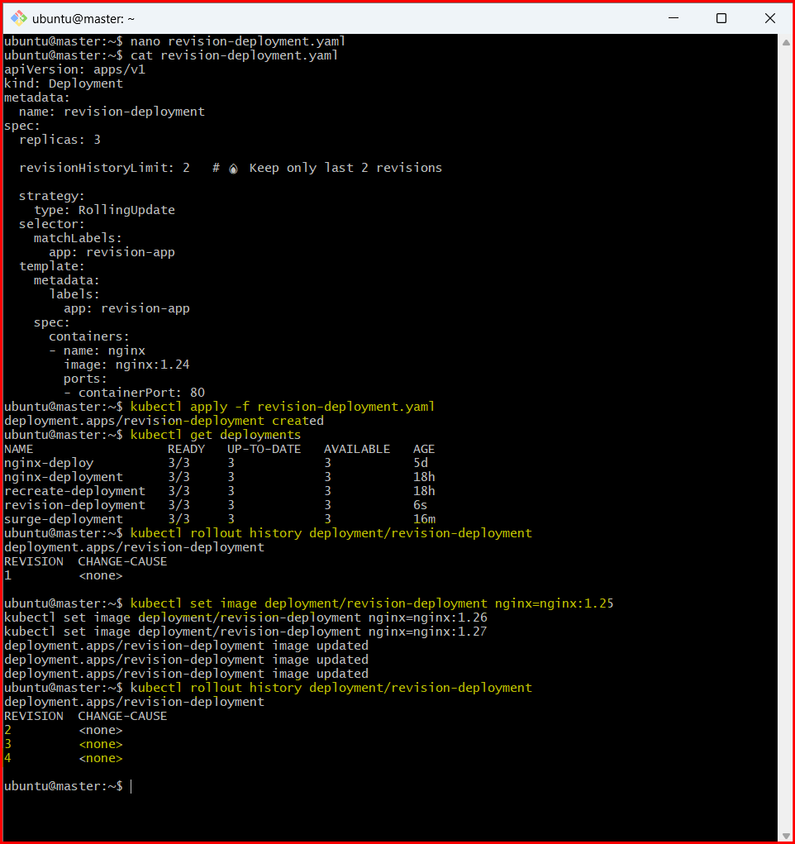
- Pause a Deployment during an update, and then resume it.

Step 1: Check your Deployment
Use an existing one (for example):
kubectl get deployments
👉 Example: nginx-deployment

🔹 Step 2: Start an update
Trigger a rollout (change image):
kubectl set image deployment/nginx-deployment nginx=nginx:1.25

🔹 Step 3: Pause the Deployment 🔥
kubectl rollout pause deployment/nginx-deployment

🔹 Step 4: Verify it is paused
kubectl describe deployment nginx-deployment
👉 Look for:
Paused: true

🔹 Step 5: Make more changes (while paused)
Example: change image again:
kubectl set image deployment/nginx-deployment nginx=nginx:1.26
👉 These changes are not applied yet

🔹 Step 6: Check rollout status
kubectl rollout status deployment/nginx-deployment
👉 It will not progress because it's paused

🔹 Step 7: Resume the Deployment ✅
kubectl rollout resume deployment/nginx-deployment

🔹 Step 8: Watch rollout
kubectl rollout status deployment/nginx-deployment
👉 Now Kubernetes applies all pending changes
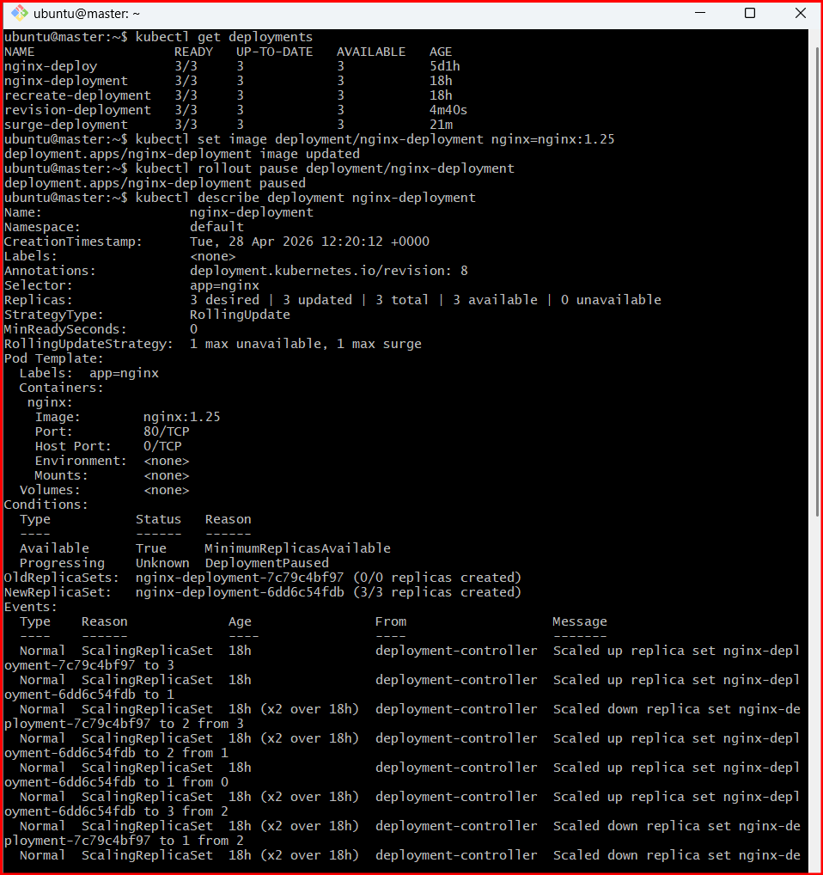

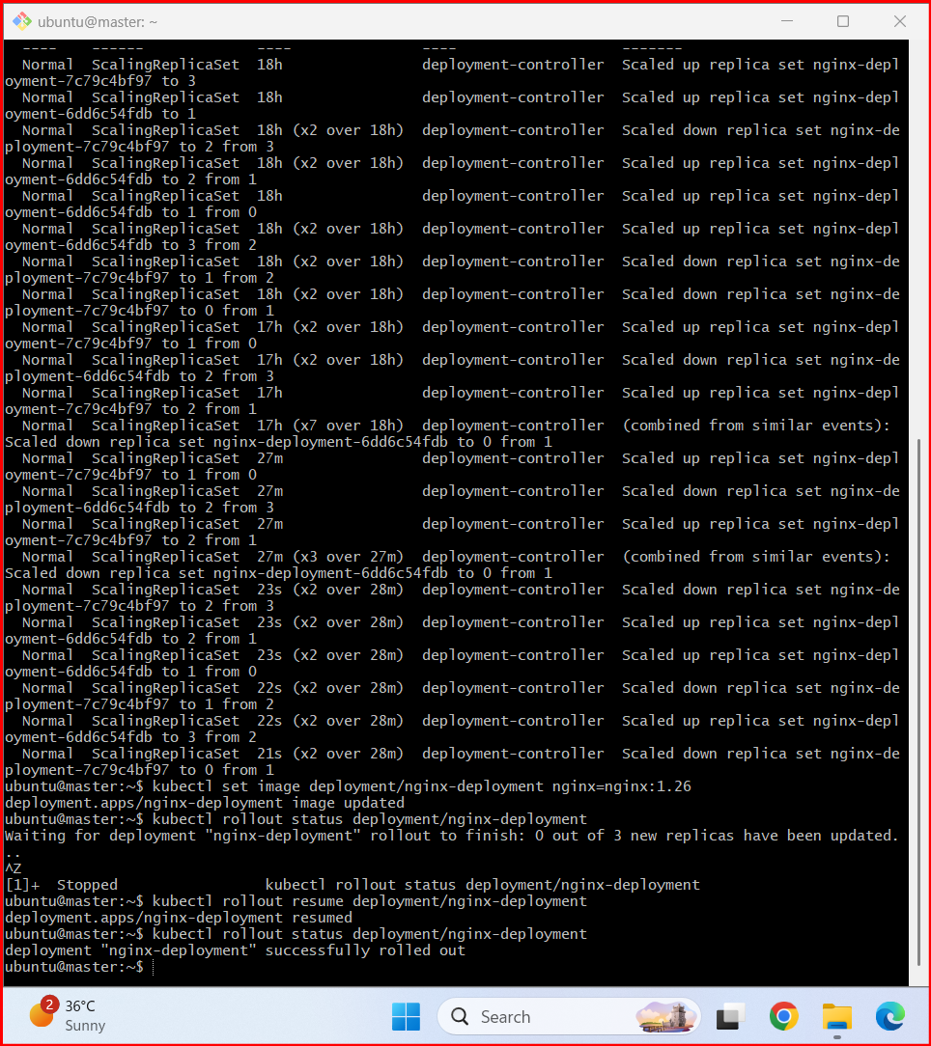
- Create a pod using resource requests for memory and CPU, and observe how the scheduler assigns it to a node.

Step 1: Create YAML file
nano resource-pod.yaml

🔹 Step 2: Add resource requests
Paste this:
apiVersion: v1
kind: Pod
metadata:
name: resource-pod
spec:
containers:
- name: nginx
image: nginx:latest
resources:
requests:
cpu: "500m" # needs 0.5 CPU
memory: "256Mi" # needs 256MB RAM
limits:
cpu: "1" # max 1 CPU
memory: "512Mi" # max 512MB RAM
ports:
- containerPort: 80

🔹 Step 3: Apply Pod
kubectl apply -f resource-pod.yaml

🔹 Step 4: Check Pod status
kubectl get pods
👉 Wait until:
resource-pod 1/1 Running

🔹 Step 5: See which node it was scheduled on 🔥
kubectl get pod resource-pod -o wide
👉 Output shows:
NAME NODE
resource-pod worker-node-1

🔹 Step 6: Describe Pod (IMPORTANT)
kubectl describe pod resource-pod
Look for:

👉 Node assignment
Node: worker-node-1

👉 Scheduling events
Events:
Normal Scheduled Successfully assigned default/resource-pod to worker-node-1

